**Title:** Multiplayer Online Battle Arena Gaming

**Methods:**

* Observation by having matches with different people in different games.
* Observing people playing different MOBAs.
* Tracking how long matches from different MOBA games take on average.
* Interviewing various MOBA gamers who play different MOBAs.

**Insights and Breakdowns:**

* The amount of toxicity a match can vary between each individual’s personality.
* There are noticeable skill differences when jumping from one MOBA to another as each game offers different mechanics.
* Casual Players tend to have a hard time getting into or having fun in MOBA games, due to the usual toxicity from other players. Mobile Legends’ players are an exception.
* Poor time-management of their hobbies leading to an overall decrease in productivity.
* League of Legends sometimes have extreme cases of nerfing or buffing champions.
* Poor internet connection leads to having poor user experience in game.

**Unmet Needs Identified:**

* League of Legends severely needs balance.
* DOTA 2 is not beginner friendly and needs a way for new players to get acquainted to its mechanics, just like how League of Legends forces its players to play AI matches so they don’t get a bad user experience and quit the game shortly after.
* Finding a way to keep the skill floor low while keeping the skill ceiling high and still be enjoyable.
* 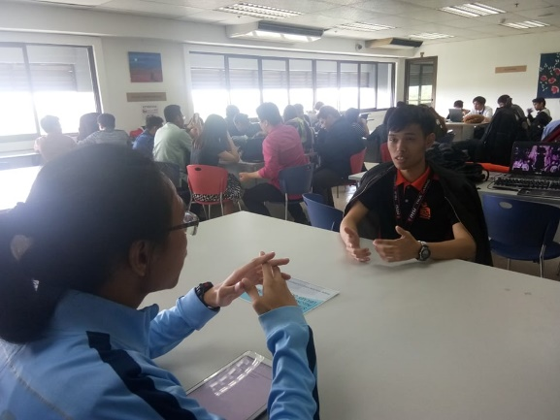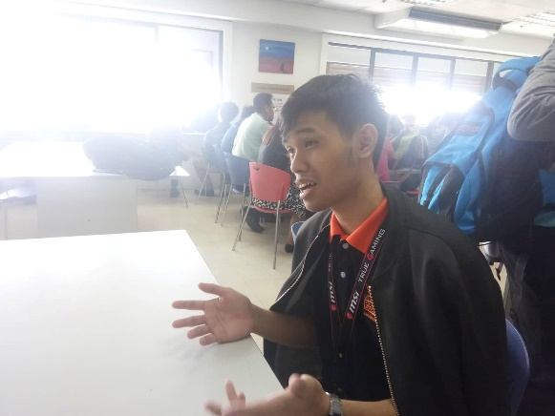Find a way to stabilize or compensate for internet lag or issues.

Respondent A:

Name: Kean Coria

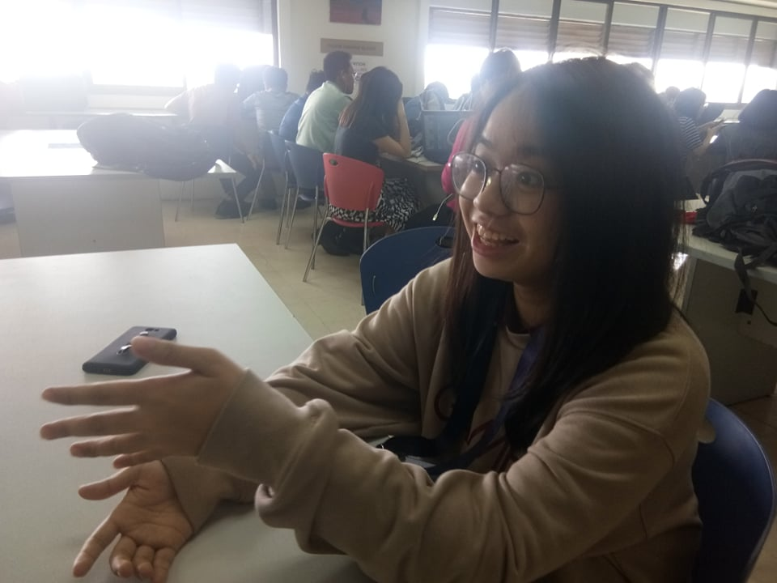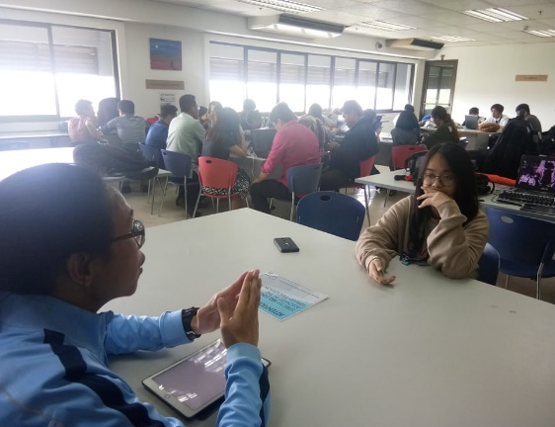Respondent B:

Name: Altaire Reyes

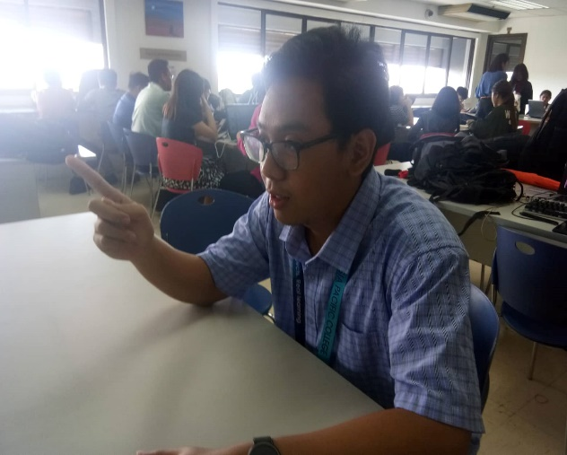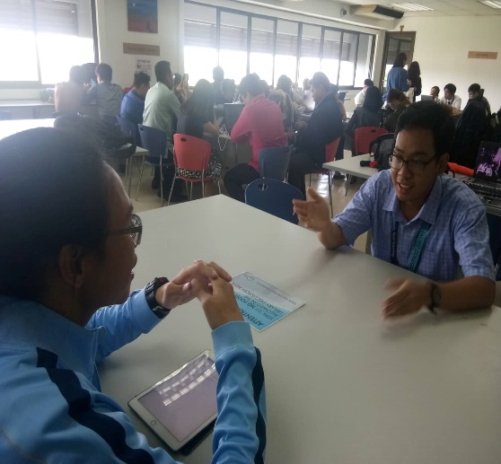Respondent C:

Name: Lloyd Carganilla